Power BI Service App setup
The document presents application configuration for reports sourcing the data from Datamart.
Our reports
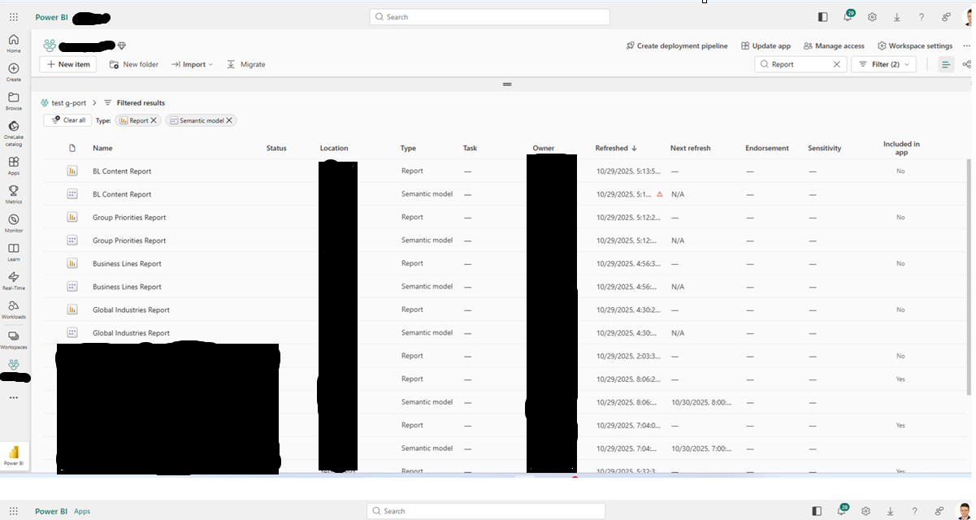
Go to update app. The option of adding the content enable select/deselect reports for app.
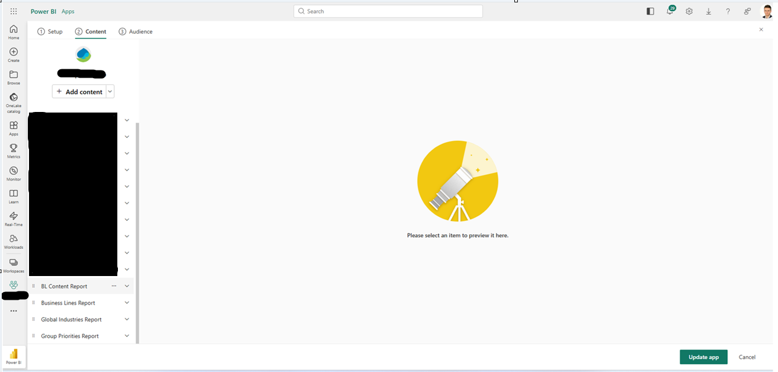

Add reports to specific audience. Hide/unhide for particular tab.
